WEEK # 1 Wednesday July 15th, 2026

Dialogue

Topic: Introducing Yourself and Your School

Student 1: Good morning, everyone!

Student 2: Good morning! Today we are going to talk about ourselves and our school.

Student 1: My name is Samuel. I am 14 years old, and I am in sixth grade.

Student 2: My name is Ross. I am 15 years old, and I am in seventh grade.

Student 1: My favorite subject is social studies because I like learning about countries.

Student 2: My favorite subject is Science because I enjoy doing experiments.

Student 1: In my free time, I like playing soccer and listening to music.

Student 2: I like reading books and drawing pictures.

Student 1: We study hard, respect our teachers, and help our classmates.

Student 2: We are proud of our school because it is a great place to learn and make friends.

Student 1: Thank you for listening!

Student 2: Do you have any questions?

Homework
Practice the dialogue

Activity #2 Wednesday July 22nd, 2026
STORY
- Listen and read. CD 1, 7
1
Kim: What are you doing, Max? Aren’t you working on your project?
Max: I was thinking about our last adventure with Zack and Jill. I love going on adventures. We went to so many exciting places, I love travelling through space and do you remember when we went to ancient Greece?
Kim: Yes, I do. It was fantastic. Then we went to Dream City and met Pip. We discovered how the world might be one day, and that we should project the environment.
Max: I don’t know!

2
Kim: Come on. Let’s take Scott for a walk in the forest. Here are your trainers. Some fresh air will help you. We can decide together.
Max: I know! Let’s go camping! I´ll get my tent.
Kim: No adventures today, Max. You have to work to do.
Max: I hope Zack and Jill come back soon. They can help me with my project.

Remember!
3
Jill: It’s very quiet here today, isn’t it?
Zack: Dad´s in his workshop. He’s building a new computer for the spaceship. Mum, Grandma Grace and Grandpa Sam are going to the zoo.
Jill: Really? Wow, let's do something exciting, too. Come on, Zack!

4
Zack: Didn’t you tell me last time, “No more adventures”?
Jill: No, I didn't. That was Max. I love adventures!
Zack: OK, let me just finish this and we can go visit them. Bring my tools to the spaceship.
Jill: You can finish it later. Come on!

2) Listen again and circle the correct words. CD 1, 8

- What are you doing, Max? Aren’t you working on your project / song/ painting?
- Let’s take Scott for a walk in the lake / mountains/ forest.
- Mum, Grandma Grace and Grandpa Sam are going to the museum / supermarket/ zoo.
- Wow! I know, let’s do something boring / exciting/ surprising, too..
- Bring my tools / trainers/ tent to the spaceship.

Homework
Underline the verb “to be” in the story.

Week # 3
- Write the Most Important Greetings for Teenagers in your notebook then practice 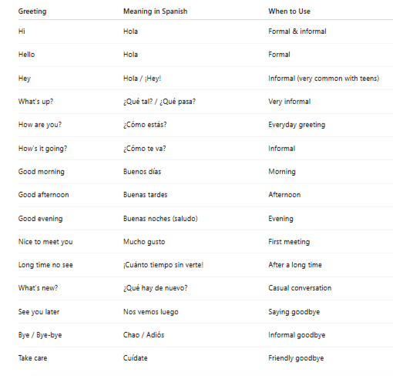

- Short Dialogs

Dialogue 1: First Meeting
A: Hi! My name is Laura. What’s your name?
B: Hi Laura! I’m Mateo. Nice to meet you.
A: Nice to meet you too!

Dialogue 2: At School
A: Hey! How are you today?
B: I’m good, thanks! And you?
A: I’m great!

Dialogue 3: Casual Teen Conversation
A: What 's up?
B: Not much. Just studying.
A: Cool!

Dialogue 4: Introducing a Friend
A: This is my friend Sara.
B: Hi Sara!
C: Hi! Nice to meet you!
- Role Play (Teacher & Student)
Teacher: Hello! What’s your name?
Student: Hi! My name is ______.
Teacher: Nice to meet you!
Student: Nice to meet you too!
Teacher: How are you today?
Student: I’m fine, thank you!
- Writing Activity
Complete the form:
- Name: __________
- Age: __________
- Favorite hobby: __________
- How are you today? __________

5. WARM UP – Match the Greetings (5 min)
Match the greeting with its meaning in Spanish.
- Hi ______ a. ¿Cómo estás?
- Good morning ______ b. Hola
- How are you? ______ c. Buenos días
- Nice to meet you ______ d. Mucho gusto
- What 's up? ______ e. ¿Qué tal?
6. LISTENING
Listen and repeat the dialogue:
A: Hi! My name is Sofia. What’s your name?
B: Hi Sofia! I’m Juan.
A: Nice to meet you!
B: Nice to meet you too!
Circle the correct answer:
- The girl’s name is:
a) Maria b) Sofia c) Ana
- The boy’s name is:
a) Juan b) Carlos c) Pedro

7. SPEAKING – Introduce Yourself
Practice with a partner or the teacher.
Model: Hello! My name is __________. I am ______ years old. I am from __________.

8. READING
Read the text and answer the questions.
"Hello! My name is Lucas. I am 11 years old. I am from Colombia. I like soccer and music. I am friendly and happy."
Answer:
- What is his name? __________________
- How old is he? __________________
- Where is he from? __________________
- What does he like? __________________

9. Personal pronouns (check and play)
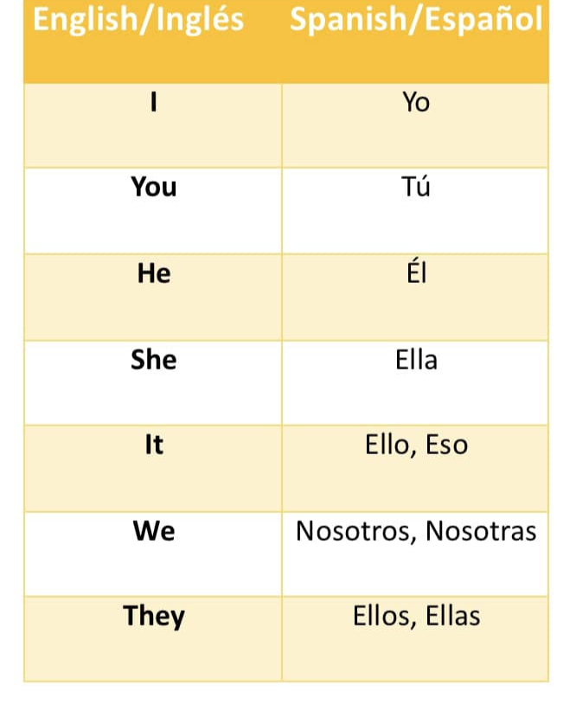

https://wordwall.net/es/resource/59409673/personal-pronouns/personal-pronouns-spanish

10. Verb to (be uses)

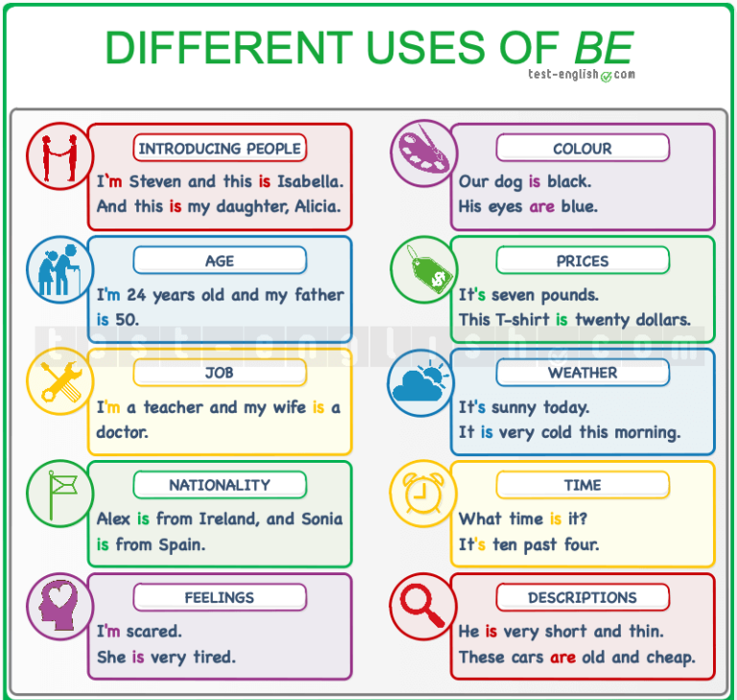

11. Verb to be (am/ is/ are)
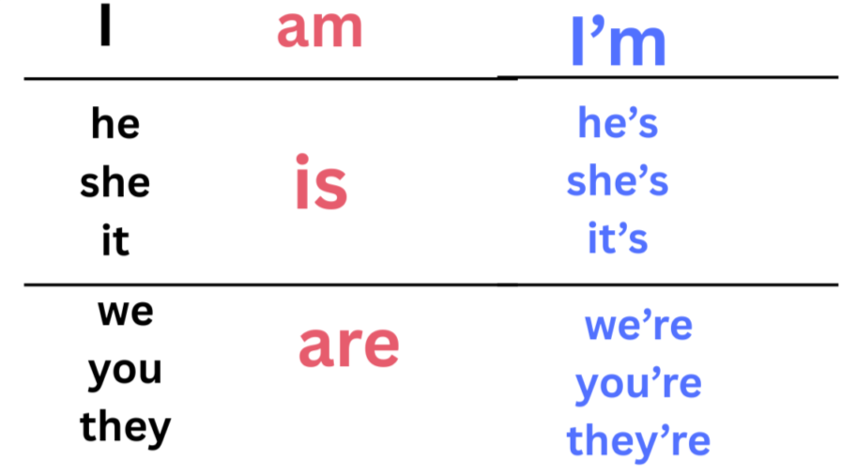

12. Verb to be (Structure)

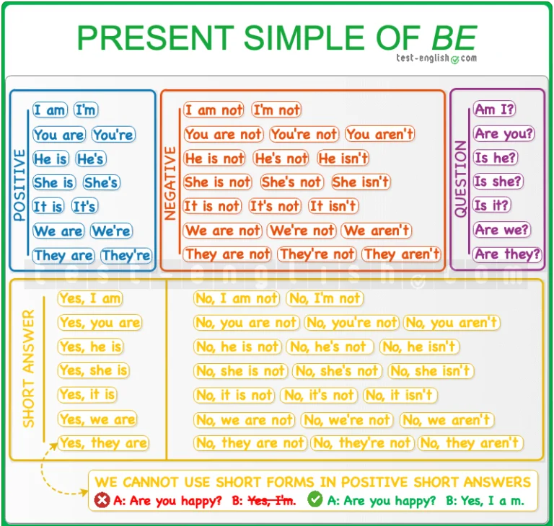

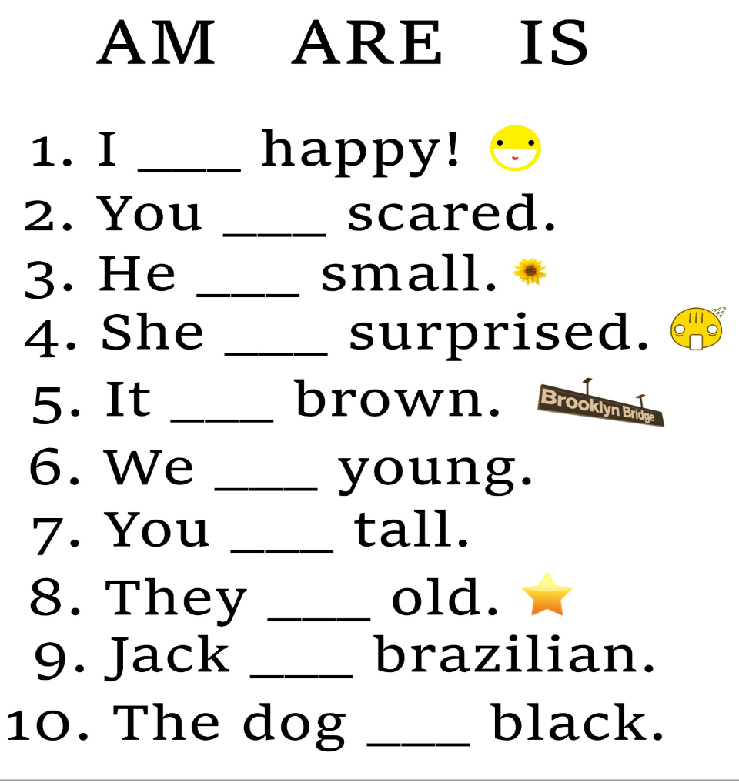
13. Verb to be activity

HOMEWORK
Copiar en el cuaderno los puntos 2, 3, 5, 6,7,8,9,10,11, 12 y 13 (si desea puede imprimir los cuadros) Practicar los diálogos y completar los puntos que dice writing. Realizar los siguientes ejercicios completando la forma correcta del verbo to be (Am, Is, Are)
- I ______ a student from Brazil.
- My parents ______ rich.
- My mother ______ a good person.
- Philip ______ short and very fat.
- You ______ very strong.
- She ______ tall and thin.
- The bird ______ blue and yellow.
- We ______ in the park.
- David ______ happy.
- ______ you Spanish?.
- My brother and I ______ at home.
- The cat ______ on the table.
- It ______ a very nice day.
- Peter and Mark ______ brothers.
- I ______ 14 years old.

WEEK # 4

Topics
- Countries & Nationalities
- Verb to be (affirmative, negative, interrogative)
- Possessive adjectives
- Family vocabulary⁰

https://www.youtube.com/watch?v=H0Hi-eDrzDo
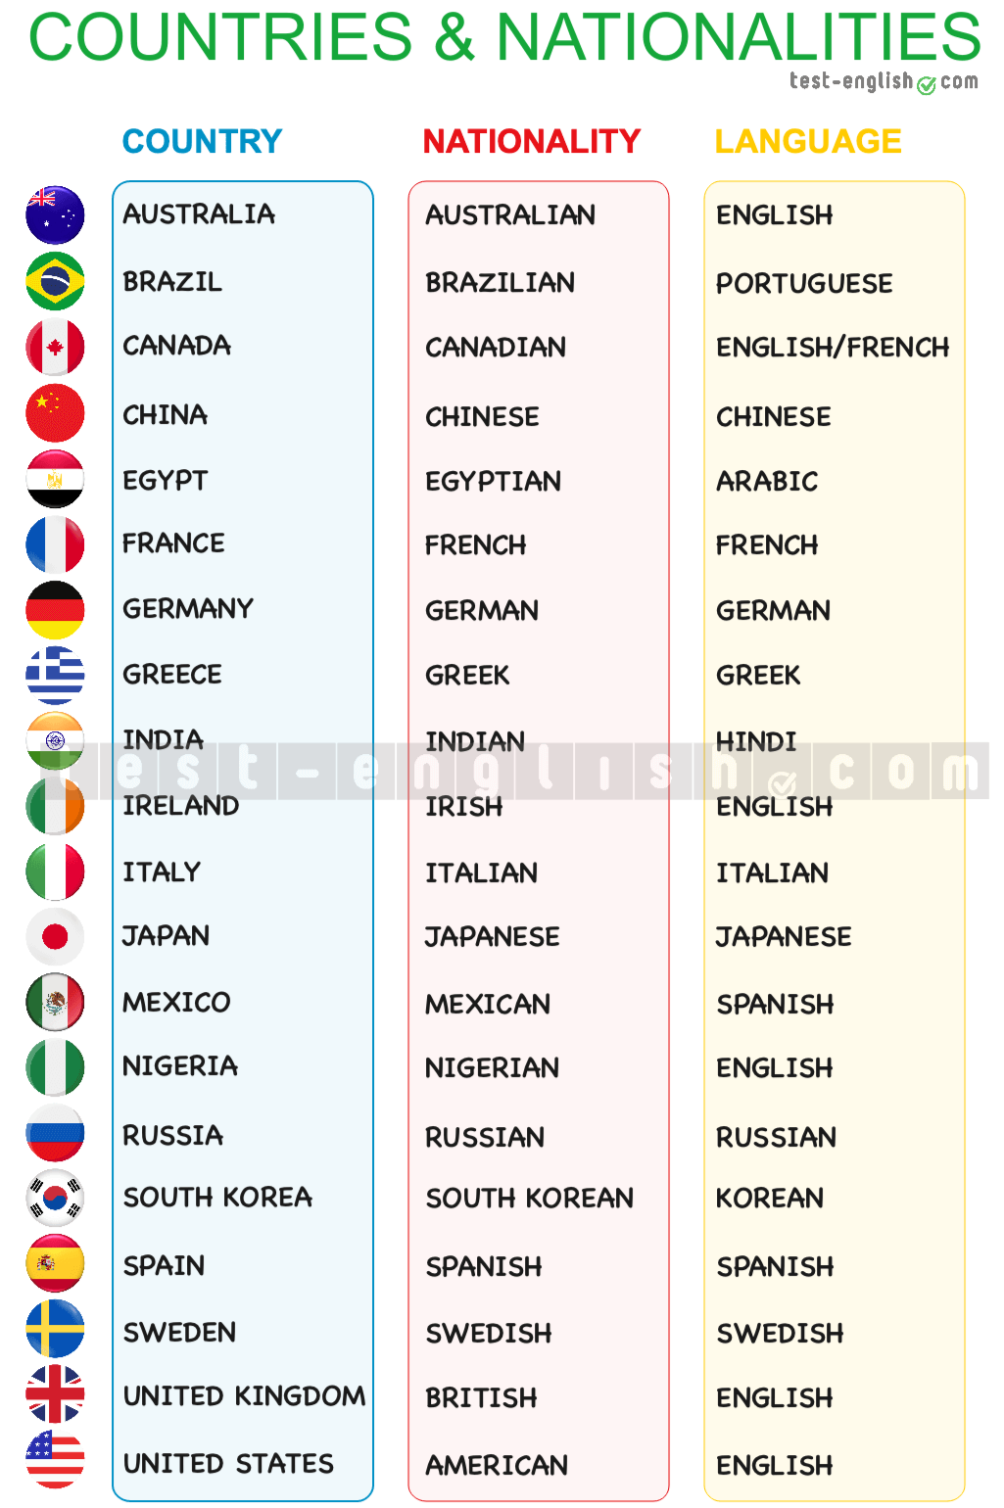
Activity: “Where Are You From?”
Watch this video
https://www.youtube.com/watch?v=H0Hi-eDrzDo
PART 1 – Match the Country and Nationality
Match the country with the nationality.
- Brazil
- Japan
- Mexico
- United States
- Italy
- China
a. American
b. Japanese
c. Brazilian
d. Mexican
e. Italian
f. Chinese
PART 2 – Verb To Be (Affirmative & Negative)
Complete the sentences with am / is / are.
- She ______ Brazilian.
- They ______ Mexican.
- I ______ American.
- He ______ Italian.
- We ______ Japanese.
Now write the negative form:
- She ______ ______ Brazilian.
- They ______ ______ Mexican.
- I ______ ______ American.
PART 3 – Interrogative Form
Write the questions and short answers.
Example:
She is French. → Is she French? Yes, she is.
- He is Chinese.
→ ____________________________
→ ____________________________
- They are American.
→ ____________________________
→ ____________________________
- You are Spanish.
→ ____________________________
→ ____________________________
PART 4 – Possessive Adjectives
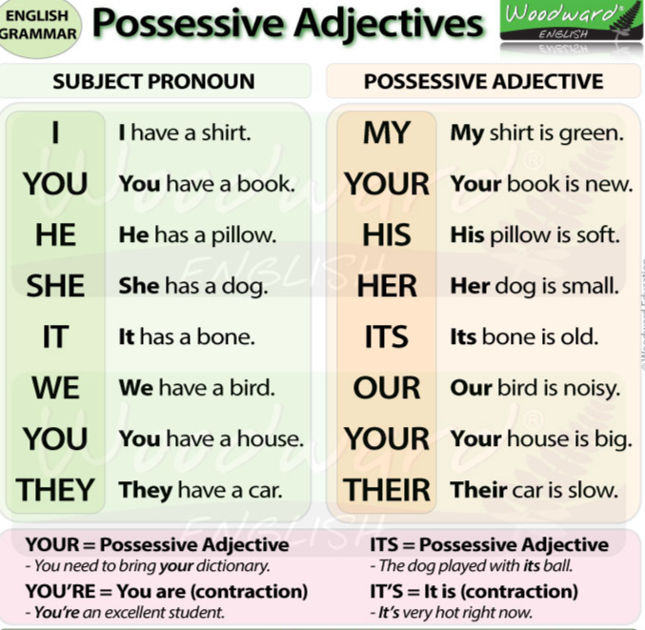
Complete with: my, your, his, her, our, their
- I am from Brazil. ______ nationality is Brazilian.
- She is from Italy. ______ nationality is Italian.
- They are from Japan. ______ nationality is Japanese.
- We are from Mexico. ______ nationality is Mexican.
- He is from China. ______ nationality is Chinese.
PART 5 – Speaking Activity
Student A and Student B ask and answer:
- Where are you from?
- What is your nationality?
- Are you ______?
- Is your mother Colombian?
- Are your friends Mexican?
Example dialogue:
A: Where are you from?
B: I am from Mexico.
A: What is your nationality?
B: My nationality is Mexican.
PART 6 – MY FAMILY AROUND THE WORLD

PART A – Complete the Sentences
Complete using family words and correct form of verb to be.
- My __________ is my mother’s mother.
- My father’s brother is my __________.
- My sister’s son is my __________.
- My mom __________ Colombian.
- My cousins __________ Brazilian.
PART B – Possessive Adjectives
Complete with: my, your, his, her, our, their
- She is my aunt. ______ husband is Italian.
- They are my grandparents. ______ house is big.
- He is my brother. ______ nationality is Mexican.
- I love ______ family.
PART C – Speaking
Student present 3 sentences:
- My mother is Colombian.
- Her nationality is Colombian.
- My cousins are American.

HOMEWORK
“MY INTERNATIONAL FAMILY PROJECT”
Students must complete ALL parts.

PART 1 – Family Tree
Draw your family tree including at least:
- Mom
- Dad
- Brother/Sister
- Grandma/Grandpa
- Uncle/Aunt
- Cousin
Write 2 sentences for each person:
Example:
This is my mother. She is Colombian.
Her nationality is Colombian.
Minimum: 12 sentences
PART 2 – Verb To Be Practice
Write:

Write 10 affirmative sentences
Example:
My uncle is Mexican.
My grandparents are Colombian.
Write 10 negative sentences
Example:
My aunt is not Brazilian.
My cousins are not Japanese.

Write questions + answers
Example:
Is your father Colombian? Yes, he is.
Are your cousins American? No, they aren’t.

PART 3 – Possessive Adjectives Paragraph
Write a paragraph (8–10 lines):
Example structure:
My name is ______.
I am Colombian.
My mother is Colombian. Her nationality is Colombian.
My father is ______. His nationality is ______.
I love my family because…
PART 4 – Creative Writing
Imagine you have family members from different countries.
Example:
My aunt is from Italy. She is Italian.
My cousin is from Japan. He is Japanese.
Their language is Japanese.
Write at least 10 sentences.

PART 5 – Presentation Preparation
Student must prepare a short oral presentation (1–2 minutes):
- Introduce yourself
- Talk about 3 family members
- Use verb to be
- Use possessive adjectives
- Use at least 3 nationalities

PART 6 – Practice
- Practice the vocabulary about family
- Print or draw the pictures below.

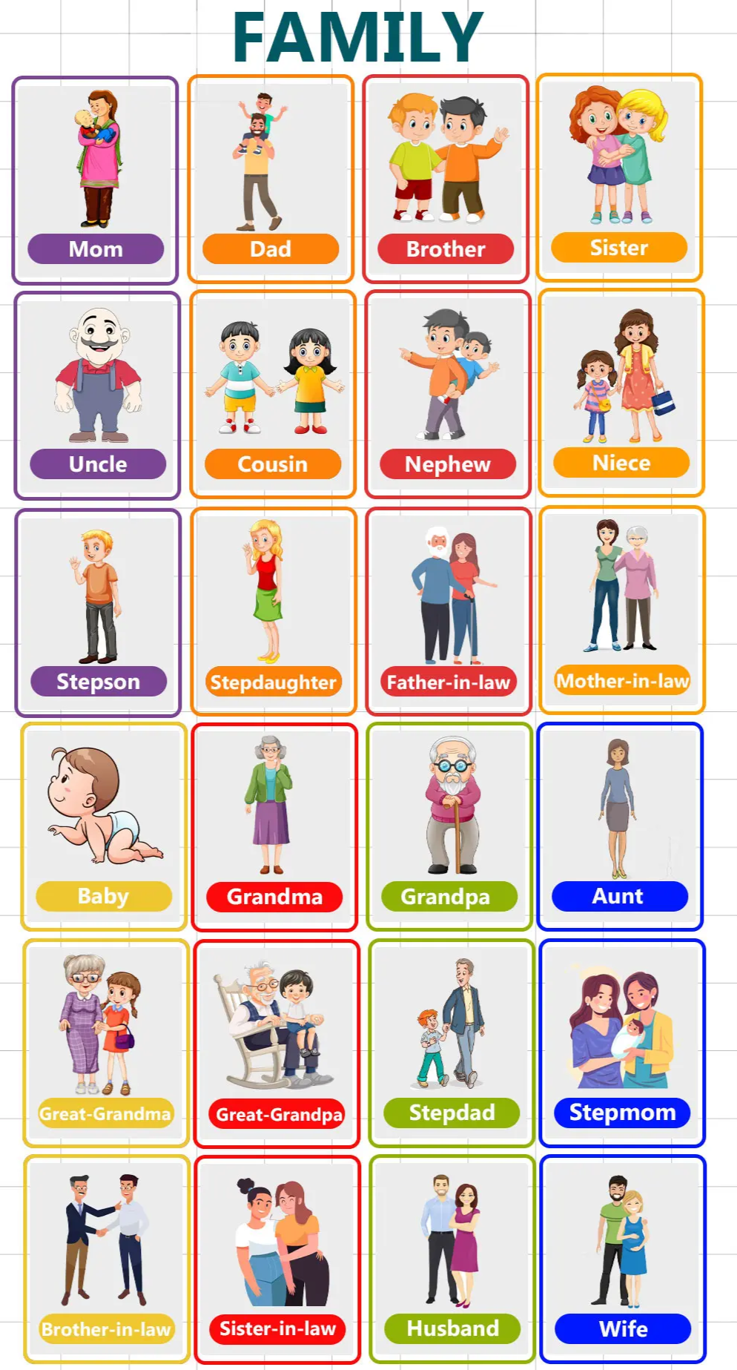

WEEK # 5

Topics
- Daily Routines
- Present Simple
- Time Expressions

Warm-up
Questions

  - What time do you wake up?
  - What do you do in the morning? https://wordwall.net/es/resource/2954544/daily-routine
You will answer orally: Example:
  - I wake up at 6:00 a.m.
  - I brush my teeth.
  - I have breakfast.

Common routines:

  - Wake up
  - Take a shower
  - Brush my teeth
  - Have breakfast
  - Go to school
  - Do homework
  - Have dinner
  - Go to bed

Review class # 4

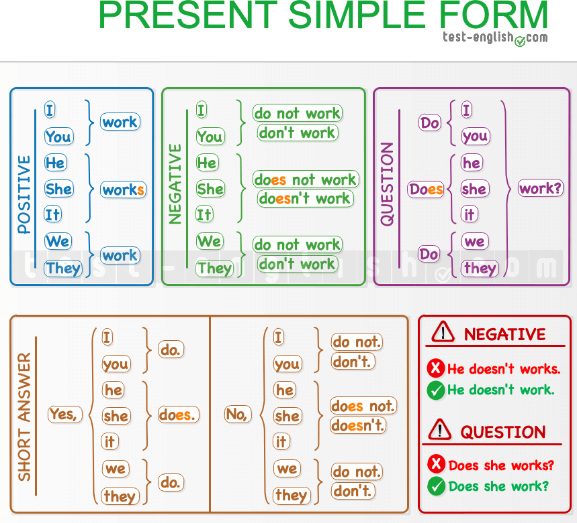
Grammar Explanation

Present Simple – Daily Routines

Structure:

I / You / We / They + verb

Examples:

- I wake up at 6:00 a.m.
- I go to school at 7:00 a.m.
- I do my homework in the afternoon.

Time Expressions

- In the morning
- In the afternoon

- In the evening
- At night
- At 6:00 a.m. / At 7:30 p.m.

Example sentences:

- I have breakfast in the morning.
- I watch TV in the evening.
- I go to bed at 9:00 p.m.

https://wordwall.net/es/resource/2308735/jumbled-sentences-daily-routines

Guided Practice
Students complete the sentences:

- I wake up at .
- I brush my teeth at .
- I go to school at .
- I do my homework in the .
- I go to bed at .

My Daily Routine Poster
Instructions

Create an illustrated routine in your notebook. You must:
- Draw 5 daily activities.
- Write the sentence under each drawing.
- Include time expressions.

Example:

- I wake up at 6:00 a.m.
- I have breakfast in the morning.
- I go to school at 7:00 a.m.
- I do my homework in the afternoon.
- I go to bed at 9:00 p.m.

Speaking Practice
Work in pairs. Student A asks:

  - What do you do in the morning?
  - What time do you go to bed?

Student B answers:

  - I wake up at 6:00 a.m.
  - I go to bed at 9:00 p.m.

Then they change roles.

Homework
Project: My Daily Routine Book

You will create a small illustrated book about your daily routine.

Instructions:
- Use 4–6 pages (notebook or sheets of paper).
- Each page must include:
  - One drawing
  - One sentence in Present Simple
  - One time expression

Example pages:

Page 1
I wake up at 6:00 a.m.

Page 2
I have breakfast in the morning.

Page 3
I go to school at 7:00 a.m.

Page 4
I do my homework in the afternoon.

Page 5
I watch TV in the evening.

Page 6
I go to bed at 9:00 p.m.
Week 6: March 18th, 2026
Topic: Adverbs of Frequency
Adverbs:
- Always (siempre)
- Usually (usualmente)
- Often (a menudo)
- Sometimes (a veces)
- Hardly ever (casi nunca)
- Never (nunca)
Warm-up Video https://www.youtube.com/watch?v=o7qHfTIjpJs
- What do you do every day?
- Do you watch TV every day?
Explanation
Adverbs of frequency tell us how often we do things.
Structure:
Subject + adverb + verb
Example:
- I always wake up at 6:00 a.m.
- She sometimes plays soccer.
Important:
- The adverb goes before the main verb
Example
I sometimes watch TV.
- With verb to be, it goes after:
Example
I am always happy

Speaking Activity
Dialogue Practice
Teacher Katherin: What do you do in the morning?
Rousse: I always wake up at 6:00 a.m.
Teacher Katherin: Do you watch TV every day?
Rousse: No, I sometimes watch TV.
Teacher Katherin: Do you do your homework?
Rousse: Yes, I usually do my homework.
Teacher Katherin: Do you play sports?
Rousse: I often play sports.
Teacher Katherin: Do you eat vegetables?
Rousse: I hardly ever eat vegetables.
Teacher Katherin: Do you go to bed late?
Rousse: No, I never go to bed late.
Practice Activities
Activity 1: Complete the sentences
- I _______ wake up early. (always)
- She _______ plays video games. (sometimes)
- We _______ eat fast food. (never)
- They _______ study English. (often)
- He _______ goes to bed late. (hardly ever)
Activity 2: Order the sentence
- always / I / breakfast / eat
- TV / sometimes / watch / I
- never / late / am / I
- often / she / reads / books
- play / we / usually / soccer

Activity 3: Choose the correct option
- I (always / never) brush my teeth every day.
- She (sometimes / never) eats pizza, but not always.
- They (often / never) go to school.
- I (hardly ever / always) do exercise (almost never).
- He (usually / never) studies after school.
Activity 4: Write sentences
Write 5 sentences about your routine using:
(always, usually, often, sometimes, never)
Activity 5: Personal questions
Answer the questions:
- How often do you watch TV?
- How often do you do homework?
- How often do you play?
- How often do you eat vegetables?
- How often do you read books?
Homework
Short Presentation
My Routine
Create a short presentation about your daily routine using adverbs of frequency.
Write at least 10 sentences.
Example:
- I always wake up at 6:00 a.m.
- I usually brush my teeth in the morning.
- I often go to school at 7:00 a.m.
- I sometimes watch TV in the afternoon.
- I hardly ever eat junk food.
- I never go to bed late.
- I always do my homework.
- I usually eat dinner with my family.
- I often play with my friends.
- I sometimes read a book.

Week #7 Cycle 3 – Grade 6

Topic: School Life – School Subjects – Likes & Dislikes

1. Warm-up: My School

Questions

What is your favorite subject?

What subject do you have today?

Who is your favorite teacher?

Do you like school?

2. School Subjects – Vocabulary

Teach/review:

Subject Spanish

English Inglés
Math Matemáticas
Science Ciencias
History Historia
Geography Geografía
Art Arte
Music Música
P.E. Educación física
Technology Tecnología

Quick activity: Say the Spanish word and the student says it in English.

Example:

Teacher: Matemáticas!
Student: Math!

Then reverse it.

3. Likes & Dislikes

I LIKE

I like English.

I love Science.

My favorite subject is Art.

I DON'T LIKE

I don't like Math.

I don't like History.

Strong opinions

I love...
I like…
It's OK.
I don't like...
I hate...

Grammar rule:

I + like/love/hate + subject

Examples:

✅ I like Music.
✅ I love English.
❌ I likes English.

4. Activity: Subject Survey

Table:

Subject ❤️ Love 👍 Like 😐 OK 👎 Don't like

English ☐
Math ☐
Science ☐
History ☐
Art ☐
Music ☐
P.E. ☐

Choose an emoji for each subject.

Teacher: Do you like Science?
Student: Yes, I do. / No, I don't.

Teacher: What is your favorite subject?
Student: My favorite subject is English.

5. Speaking Challenge – "My School Day"

Complete:

Hello! My name is ______.
I am in grade ______.
My favorite subject is ______.
I like ______ because ______.
I don't like ______ because ______.
I love ______.
My school day is ______.

For a beginner, allow:
I like English.
I don't like Math.
I love Art.

6. Exit

Complete:

1. My favorite subject is __________.

2. I like __________.

3. I don't like __________.

4. I love __________.

5. I hate __________.

Homework

My Favorite Subject

Draw your favorite school subject and write 5 sentences:

My favorite subject is ______.
I like ______.
My teacher is ______.
We learn about ______.
I like it because ______.

Week # 8

Topics
Review daily routine
Adverbs of frequency
I like / I don’t like

1. Warm-up
Activity: “Mime the Routine”

1. Teacher mimes actions:

wake up

brush teeth

eat breakfast

go to school

2. Student guess: “You wake up!”
“You brush your teeth!”

3. Then the student takes turns miming.

2. Review: Daily Routine

Write on the board:

I wake up at 6:00

I eat breakfast

I go to school

I do homework

I go to bed

Question:

What do you do every day? Students answer: I wake up at 7:00

3. Adverbs of Frequency (15 minutes)

Introduce:

Always (100%)

Usually (80%)

Sometimes (50%)

Never (0%)

Examples

I always brush my teeth

I usually go to school at 7:00

I sometimes watch TV

I never eat candy at night

Activity: “Line Game”

1. Say a sentence: “I watch TV”

2. Student choose:

Always / Usually / Sometimes / Never

3. They say full sentence: “I sometimes watch TV”

4. I like / I don’t like

Write:

I like + activity

I don’t like + activity

Examples:

I like playing soccer

I don’t like doing homework

Activity: Pair Work

Students ask: Do you like ___?

Answer:

Yes, I do / No, I don’t

5. Practice Activity

Students write 5 sentences:

1. I always ______

2. I usually ______

3. I sometimes ______

4. I never ______

5. I like ______ / I don’t like ______

Homework: Daily Routine

Title: My Daily Routine

Students write 6–8 sentences:

Example:

I wake up at 6:00

I always brush my teeth

I usually go to school at 7:00

I sometimes watch TV

I like playing soccer

I don’t like cleaning my room

WEEK # 9
Topic: Likes & Dislikes + House Vocabulary + There is / There are

Warm-up

Game: “Do you like…?”
Teacher asks:

  - Do you like pizza?
  - Do you like video games?

Students answer:

  - Yes, I do / No, I don’t

Vocabulary – Parts of the House

Teach vocabulary:

  - Living room – sala
  - Kitchen – cocina
  - Bedroom – habitación
  - Bathroom – baño
  - Dining room – comedor
  - Garden – jardín
  - Garage – garaje

Activity: Students draw a simple house and label the rooms

Grammar – There is / There are
Explain:

  - There is = hay (singular)
  - There are = hay (plural) Examples:
  - There is a bed in the bedroom

  - There are two chairs in the dining room Negative:
  - There is not (isn’t)
  - There are not (aren’t) Questions:
  - Is there a sofa?
  - Are there chairs?

Likes and Dislikes
Structure:

  - I like + noun
  - I don’t like + noun Examples:
  - I like my bedroom
  - I don’t like the kitchen Add:
  - I love / I hate (optional)

Practice Activity (20 min)

Activity 1: Complete
Fill in the blanks:

- There a sofa in the living room
- There two beds in the bedroom
- I (like / don’t like) the bathroom
- There a table in the kitchen
- I my house Activity 2: Speaking In pairs:
Student A asks:

  - Do you like your house?
  - What is your favorite room?

Student B answers:

  - I like… / I don’t like…
  - My favorite room is…

Production

Draw and Describe Your House

Students draw their house and write:

  - There is…
  - There are…
  - I like…
  - I don’t like… Example:
  - There is a bed in my bedroom
  - There are two chairs in the kitchen
  - I like my living room

Homework

My Dream House

Write 8–10 sentences:

Include:

  - 3 sentences with there is
  - 3 sentences with there are
  - 2 sentences with likes/dislikes

Example:

  - There is a big kitchen
  - There are three bedrooms
  - I like the garden
  - I don’t like sma l rooms

Week #10
Topic: Prepositions (in, on, under, next to, between) + There is / There are
1. Warm-up
https://www.youtube.com/watch?v=eUPOGjAEwqg

There is / There are | Grammar with Exercise| Learn English For Kids

- Where is the book?
- It is on the table
2. Presentation
Prepositions:
- in → dentro
- on → sobre
- under → debajo
- next to → al lado de
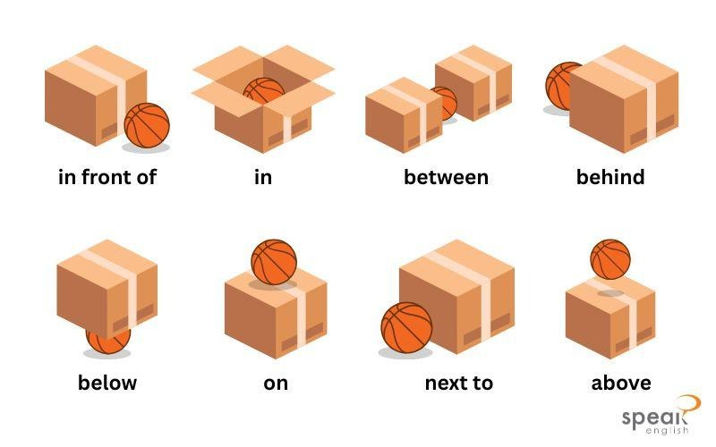
- between → entre

Examples
- The pencil is in the bag
- The book is on the table
- The ball is under the chair
- The bag is next to the desk
- The book is between the chairs
3. Grammar Focus
There is / There are
- There is → singular
  - There is a book on the table
- There are → plural
  - There are two pencils under the chair

4. Practice Game
Juego: “Find the object”
- Esconde un objeto en el salón.
- Da pistas:
  - It is under the desk
  - It is next to the chair
- La estudiante busca y dice:
  - There is a pencil under the desk
5. Production
Create 3 sentences
- 1 con in/on/under
- 1 con next to
- 1 con between
6. Wrap-up
- Where is your pencil?
- Where is your bag?
Answer
- It is…
- There is / There are…
Homework
- Draw your bedroom.
- Write 5 sentences using:
  - in, on, under, next to, between
- Use there is / there are
Example:
- There is a bed next to the window
- There are two books on the table

Week #11 Wednesday April 29th, 2026

Topic: Describing People
Grammar Focus

- Adjectives
- Have got / Has got

Project: My Favorite Character
Instructions

Choose your favorite character from a movie, cartoon, book, video game, or TV show.
Create a short description using adjectives and have got / has got.

You can draw or print a picture of the character.

Your project must include:
1. Basic Information

- Character’s name
- Where the character is from
- Why you like the character

2. Physical Description

Use adjectives and has got.

Example:

- She has got long black hair.
- He has got blue eyes.
- She is brave and intelligent.

3. Personality Description

Use at least 5 adjectives.

Examples:

- funny
- kind
- strong
- friendly
- clever

4. Complete Sentences

Write 8–10 sentences.
Example

My favorite character is Elsa from Frozen.
She is a queen from Arendelle.
She has got long blonde hair and blue eyes.
She is tall and beautiful.
Elsa is kind, brave, and intelligent.
She has got magical powers.
I like Elsa because she helps her sister and protects her kingdom.

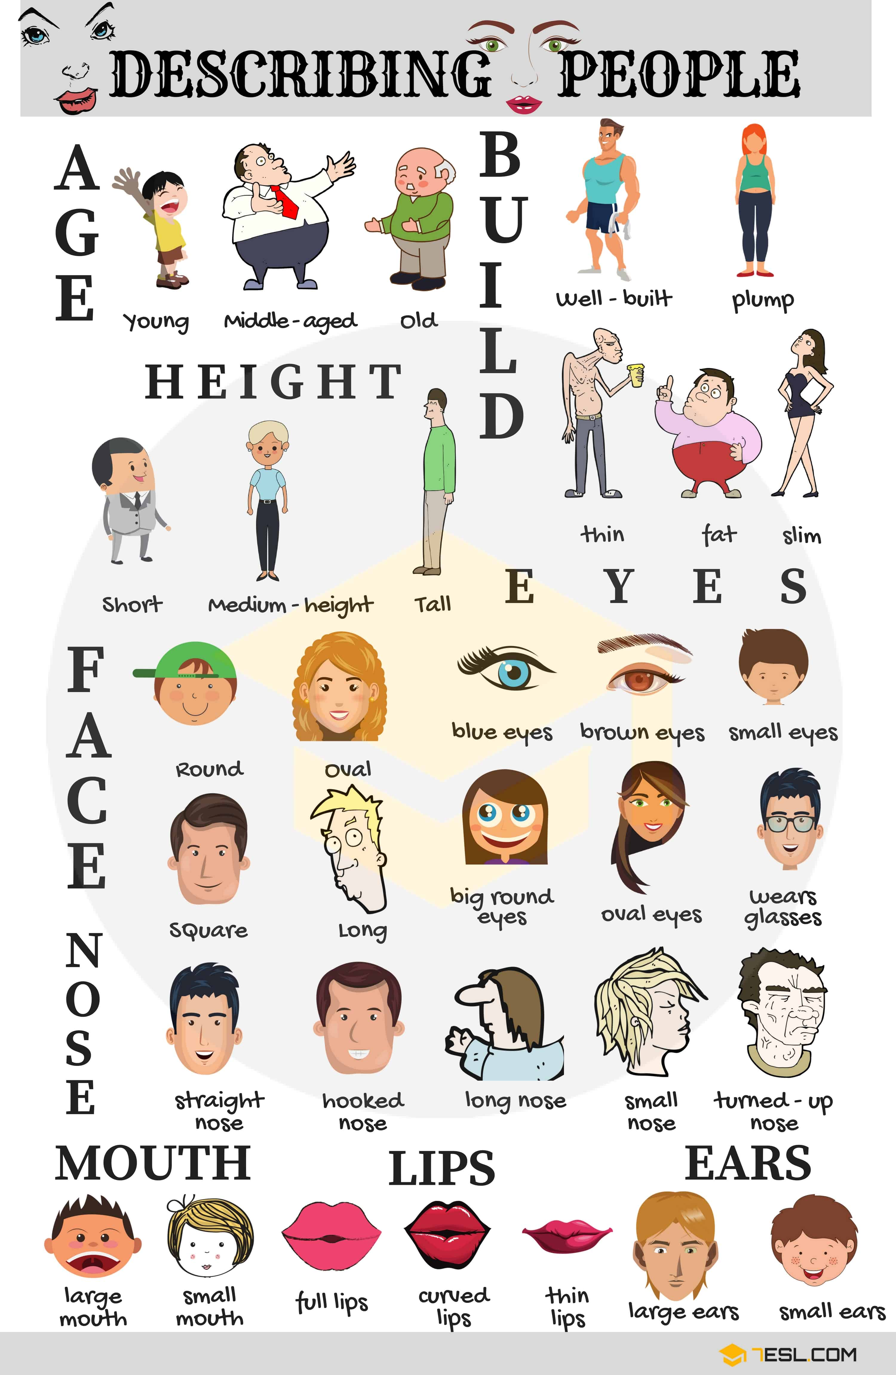

Week # 12
Topic: My Ideal House & My Favorite Person + Introduction to Food, Health & Free Time
1. Warm-up
Ask students:
- What is your favorite food? My favorite food is………
- Who is your favorite person? My favorite person is………..
- What do you like to do in your free time? I like to……….

2. Vocabulary Review
Write and practice:

House
- kitchen, bedroom, living room, garden

People
- mother, father, friend, teacher

Food & Health
- fruits, vegetables, water, exercise

Free Time
- play soccer, watch TV, read, listen to music

3. Structure Practice

simple structures:
- I like / I don’t like
- My favorite person is…
- In my ideal house, there is / there are…
- He/She likes…
Example:
- My favorite person is my mom. She likes cooking.
- In my ideal house, there is a big kitchen.
- I like pizza and playing soccer.

4. Mini Project
Title: My Ideal House and My Favorite Person
Create a small poster or notebook activity:

Must include:
- Drawing of their ideal house
- Drawing of their favorite person
- Write 5–6 sentences:
Example:
- My ideal house is big.
- There is a garden.
- My favorite person is my sister.
- She likes music.
- I like pizza and playing soccer.
Homework
Title: My Healthy Life and Free Time

Instructions:
In your notebook:

Part 1: Write (8 sentences)
- What food do you like?
- What healthy habits do you have?
- What do you do in your free time?
Example:
- I like apples and chicken.
- I drink water.
- I play soccer in my free time.

Part 2: Draw
Draw:
- Your favorite food
- One healthy activity
- One free time activity

Week #13 – Food Vocabulary
Topics
- Food Vocabulary
- Countable and Uncountable Nouns
- Some / Any
Class Plan
1. Warm-up – “What’s in your kitchen?”
- What food do you eat for breakfast?
- Do you have any fruit at home?
- What healthy food do you like?
Write vocabulary on your notebook:
apple
milk
bread
eggs rice
carrots
juice
2. Grammar Review
Countable Nouns
Foods we can count.
Examples:
- an apple
- two bananas
- three eggs
Uncountable Nouns
Foods we cannot count individually.
Examples:
- milk
- rice
- bread
- juice
Some / Any
Some | Any
Positive sentences | Questions & negatives
I have some apples. | Do you have any milk?
Examples:
- There is some rice.
- There are some carrots.
- We don’t have any soda.
3. Main Activity – Healthy Menu Challenge
Create a Healthy Menu for:
- Breakfast
- Lunch
- Dinner
The menu must include:
4 countable foods
4 uncountable foods
3 sentences with some
2 sentences with any
Students draw or decorate their menu.
Example
Breakfast
- eggs
- bread
- juice
Sentences
- There are some eggs on the table.
- There is some juice in the glass.
- We don’t have any soda.
4. Speaking Time – Presentation (5 minutes)
Present their menu to the class using complete sentences.
Example:
“My healthy menu has some vegetables and some rice. There aren’t any candies.”

Homework
“My Refrigerator at Home”
Draw 8 foods you have at home and classify them:
Countable | Uncountable
apples | milk
Then write:
- 3 sentences with some
- 2 questions with any
Example:
- There is some cheese in my refrigerator.
- Are there any apples?

Week #14
Topics: Can / Can’t – Abilities, Sports & Hobbies

1. Warm-up

Can you swim?

Can you play soccer?

Can you ride a bike?

Answer

Yes, I can.

No, I can’t.

2. Vocabulary Review
- play soccer
- dance
- swim
- ride a bike
- play basketball

- sing
- cook
- draw

Repeat pronunciation.

3. Grammar Explanation
Can = ability
I can swim.
She can dance.
Can’t = no ability

I can’t cook.
He can’t play tennis

4. Practice Activity
Complete sentences:

1. I ___ play soccer.
2. My mom ___ cook.
3. My friend ___ swim.
4. I ___ ride a horse.

(Answers: can / can’t)

Can you dance?
Can you sing?

5. Closing Game

Mime game: act out a hobby/sport, classmates guess:
Can you play basketball?
Can you swim?

Homework

Write 8 sentences:

4 sentences with can

4 sentences with can’t

Example:

I can dance.
I can’t play tennis.

Week 15: Planning a Healthy Day Topics: Routine + Food + Activities

Warm-up Healthy or Not?
Indicate whether each of these sentences is healthy or not
- Wake up at 6:00 a.m.
- Eat chips for breakfast.
- Drink wáter.
- Exercise every day.
- Sleep at 1:00 a.m.

Questions

- What do you do every day?
- What healthy food do you eat?

Presentation – Vocabulary Review

Routine
- Wake up
- Brush my teeth
- Go to school
- Do homework
- Go to bed

Food
- Fruits
- Vegetables
- Water
- Chicken
- Rice
- Juice

Activities
- Play soccer
- Ride a bike
- Read
- Exercise
- Walk

Model sentences:

- I wake up at 6:00 a.m.
- I eat fruit for breakfast.
- I play soccer in the afternoon.

Practice– Create Your Healthy Day
Students complete the schedule in their notebooks:

Time | Activity
6:00 a.m. | I wake up
7:00 a.m. | I eat a healthy breakfast
12:00 p.m. | I eat lunch
4:00 p.m. | I play soccer
9:00 p.m. | I go to bed

Instructions:

- Include at least 3 routines
- Include 2 healthy foods
- Include 2 activities

Example:

My healthy day starts at 6:00 a.m. I eat eggs and fruit. In the afternoon, I ride my bike.

Homework
Write 3 sentences about what you will do tomorrow to have a healthy day.
Example:

- I will eat fruit.
- I will drink water.
- I will exercise.

